BPO MANAGEMENT

USE CASE DIAGRAM

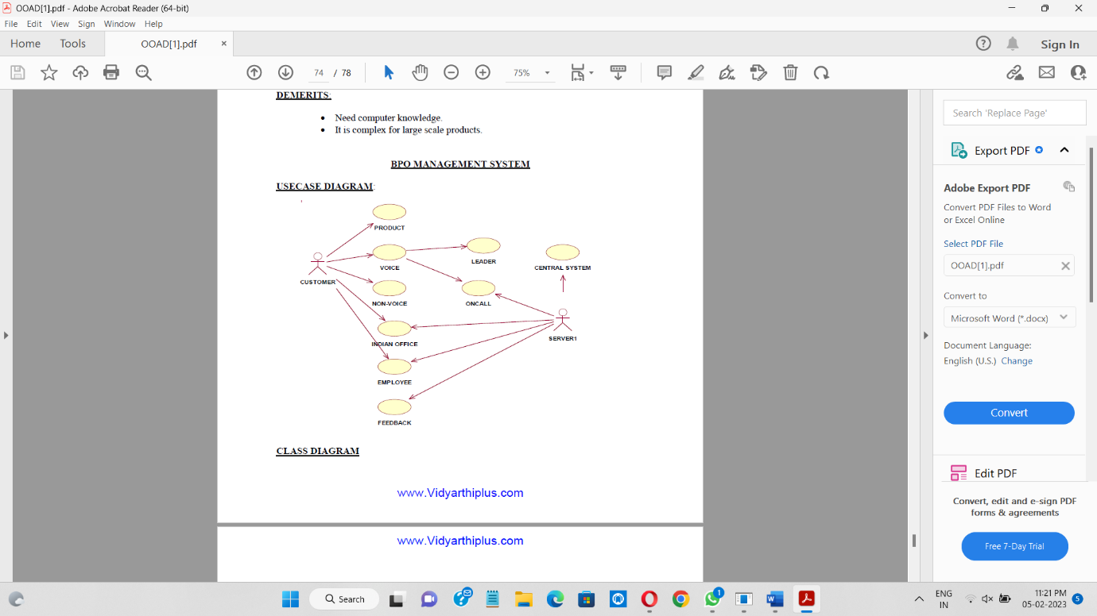

CLASS DIAGRAM

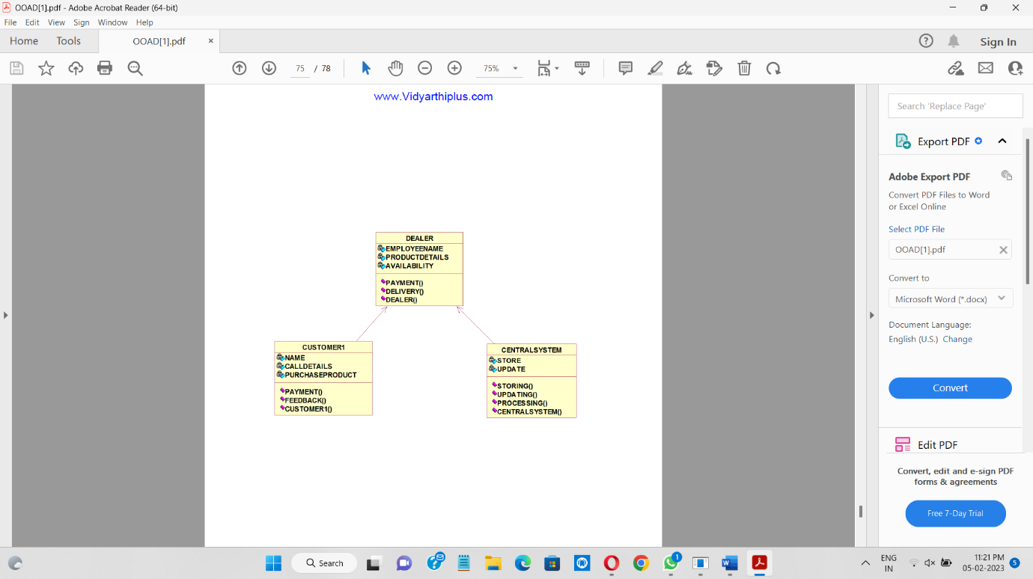

SEQUENCE DIAGRAM

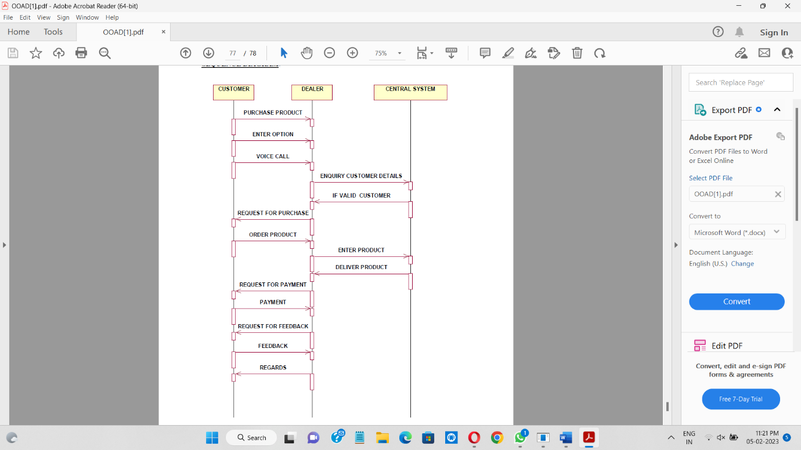

COLLABORATION DIAGRAM

